**ALERT**

* Alert is a small dialogs message box that displays an important notification on the screen to give users a certain kind of information or ask for permission to perform a certain kind of operation.
* Alert can be a validation errors,warnings,accepting an input value etc..
* Alert is an Interface
* It cannot be inspected(Because it is not HTML code,but javascript code)

**TYPES OF ALERT**

* **Simple Alert(only one option🡪Information!)**

A simple alert will show information or warning on the screen and expect the user to click on an OK button to continue an ongoing process.

[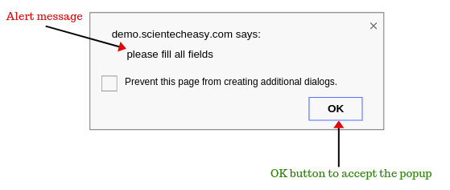](https://www.scientecheasy.com/2020/07/handle-alert-in-selenium.html/)

* **Prompt Alert(Text box+2 options🡪Data Collection +Confirmation!)**

Prompt Alert will show a message on the screen and expect the user to enter a value using sendkeys(“input…”) of selenium webdriver before continuing with an ongoing process.

[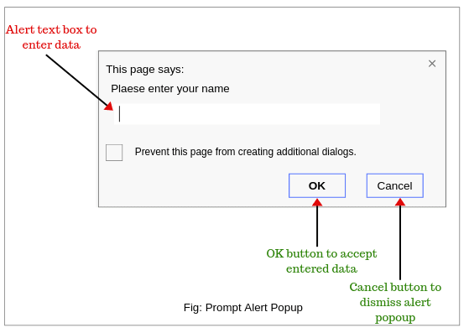](https://www.scientecheasy.com/2020/07/handle-alert-in-selenium.html/)

* **Confirmation Alert (2 options🡪Confirmation!)**

This confirmation alert will show a message on the screen and expect the user to accept or dismiss the alert before continuing with an ongoing operation.

[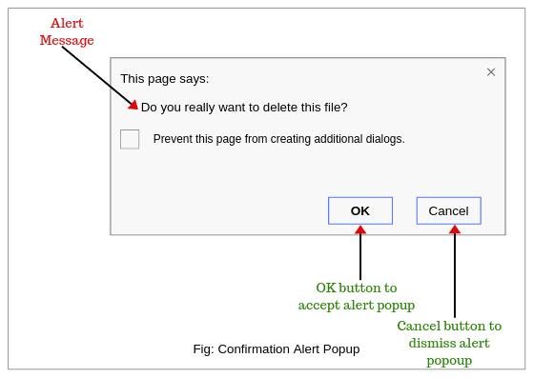](https://www.scientecheasy.com/2020/07/handle-alert-in-selenium.html/)

**Methods of Alert Interface in Selenium**

1. **void dismiss():** This method is used to clicking on the ‘Cancel’ button of the alert.

Syntax:

driver.switchTo().alert().dismiss();

1. **void accept():** This method is used to clicking on the ‘Ok’ button of the alert.

Syntax:

driver.switchTo().alert().accept();

1. **String getText():** This method is used to capture the alert message.

Syntax:

driver.switchTo().alert().getText();

1. **void sendKeys(String stringToSend):** This method is used to send or input data to the alert box.

Syntax:

driver.switchTo().alert().sendKeys(“Text”);

Note: Always clear before you type

**Limitation of Alert:** You cannot take screenshot of an Alert.

**Exceptions of Alert:**

UnhandledAlert Exception 🡪If u are interacting with DOM without closing the alert

NoAlertPresent Exception🡪If u are interacting with alert but it didn’t appear in the webpage.

**SWEET ALERT🡪 Inspectable,Click it,Can take snapshot.**